Lab: Basic Syntax, Conditional Statements and Loops
Problems for exercises and homework for the "Programming Fundamentals" course @ SoftUni.
You can check your solutions in Judge.

Student Information
You will be given 3 lines of input – student name, age, and average grade. Your task is to print all the info about the student in the following format: "Name: {student name}, Age: {student age}, Grade: {student grade}".

Examples
Input | Output
John  15  5.40 | Name: John, Age: 15, Grade: 5.40
Steve  16  2.50 | Name: Steve, Age: 16, Grade: 2.50
Marry  12  6.00 | Name: Marry, Age: 12, Grade: 6.00

Solution
First, we need a scanner, which we can use to read data from the console.
Read all the information – student name, age, and grade
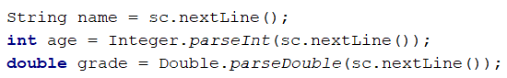
Finally, we need to print the information in the specified format

Passed
Write a program that takes as an input a grade and prints "Passed!" if the grade is equal or more than 3.00.

Input
The input comes as a single floating-point number.

Output
The output is either "Passed!" if the grade is equal or more than 3.00, otherwise, you should print nothing.

Examples
Input | Output |  | Input | Output
5.32 | Passed! |  | 2.34 | (no output)

Passed or Failed
Modify the above program, so it will print "Failed!" if the grade is lower than 3.00.

Input
The input comes as a single double number.

Output
The output is either "Passed!" if the grade is more than 2.99, otherwise, you should print "Failed!".

Examples
Input | Output |  | Input | Output
5.32 | Passed! |  | 2.36 | Failed!

Hint
We need to take a floating-point number from the console. After that, print in the else statement the appropriate message.
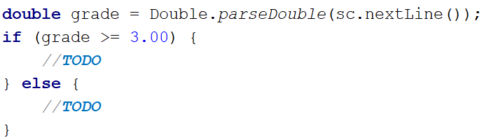

Back in 30 Minutes
Every time John tries to pay his bills, he sees on the cash desk the sign: "I will be back in 30 minutes". One day John was sick of waiting and decided he needed a program that prints the time after 30 minutes. That way he won't have to wait at the desk and come at the appropriate time. He gave the assignment to you, so you have to do it.

Input
The input will be on two lines. On the first line, you will receive the hours, and on the second, you will receive the minutes.

Output
Print on the console the time after 30 minutes. The result should be in the format "hh:mm". The hours have one or two numbers, and the minutes always have two numbers (with leading zero).

Constraints
- The hours will be between 0 and 23.
- The minutes will be between 0 and 59.

Examples
Input | Output |  | Input | Output |  | Input | Output |  | Input | Output |  | Input | Output
1  46 | 2:16 |  | 0  01 | 0:31 |  | 23  59 | 0:29 |  | 11  08 | 11:38 |  | 11  32 | 12:02

Hints
Add 30 minutes to the initial minutes that you receive from the console. If the minutes are more than 59 – increase the hours by 1 and decrease the minutes by 60. In the same way, check if the hours are more than 23. When you print, check for leading zero.

Month Printer
Write a program that takes an integer from the console and prints the corresponding month. If the number is more than 12 or less than 1 print "Error!".

Input
You will receive a single integer on a single line.

Output
If the number is within the boundaries, print the corresponding month, otherwise, print "Error!".

Examples
Input | Output |  | Input | Output
2 | February |  | 13 | Error!

Hints
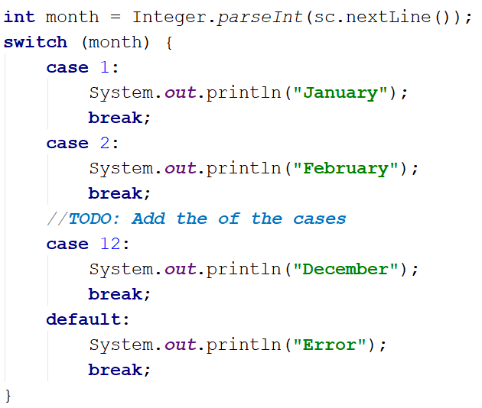

Foreign Languages
Write a program that prints the language that a given country speaks. You can receive only the following combinations: English is spoken in England and USA; Spanish is spoken in Spain, Argentina, and Mexico; for the others, we should print "unknown".

Input
You will receive a single country name on a single line.

Output
Print the language, which the country speaks, or if it is unknown for your program, print "unknown".

Examples
Input | Output |  | Input | Output
USA | English |  | Germany | unknown

Hint
Think about how you can merge multiple cases to avoid writing more code than you need to.

Theatre Promotions
A theatre is having a ticket sale, but they need a program to calculate the price of a single ticket. If the given age does not fit one of the categories, you should print "Error!". You can see the prices in the table below:
Day / Age | 0 <= age <= 18 | 18 < age <= 64 | 64 < age <= 122
Weekday | 12$ | 18$ | 12$
Weekend | 15$ | 20$ | 15$
Holiday | 5$ | 12$ | 10$

Input
The input comes in two lines. On the first line, you will receive the type of day. On the second – is the age of the person.

Output
Print the ticket price according to the table, or "Error!" if the age is not in the table.

Constraints
- The age will be in the interval [-1000…1000].
- The type of day will always be valid.

Examples
Input | Output |  | Input | Output |  | Input | Output |  | Input | Output
Weekday  42 | 18$ |  | Holiday  -12 | Error! |  | Holiday  15 | 5$ |  | Weekend  122 | 15$

Hints
We need to read two lines. The first one will be the type of day. We will convert it to lower case letters with the method "toLowerCase()". After that, we will read the person's age and declare a variable – price, which we will use to set the ticket price.
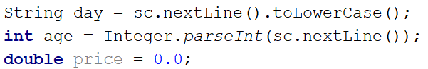
For every type of day, we will need to add different cases to check the person's age and set the price. Some age groups have equal prices for the same type of day. This means we can use logical operators to merge some of the conditions.
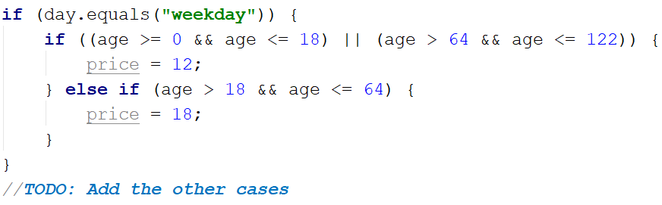
Think where and how you can use logical operators for the other cases.
We can check if the price has a value is different from the initial one. If it does, that means we got a valid combination of day and age, and the ticket price is saved in the price variable. If the price has a value of 0, then none of the cases got hit, therefore, we have to print the error message.
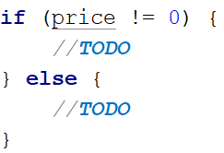

Divisible by 3
Write a program that prints all the numbers from 1 to 100, which are divisible by 3. You have to use a single for loop. The program should not receive input.

Solution
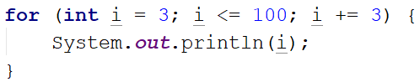

Sum of Odd Numbers
Write a program that prints the next n odd numbers (starting from 1) and on the last row prints the sum of them.

Input
On the first line, you will receive a number – n. This number shows how many odd numbers you should print.

Output
Print the next n odd numbers, starting from 1, separated by new lines. On the last line, print the sum of these numbers.

Constraints
- n will be in the interval [1…100]

Examples
Input | Output |  | Input | Output
5 | 1  3  5  7  9  Sum: 25 |  | 3 | 1  3  5  Sum: 9

Hints
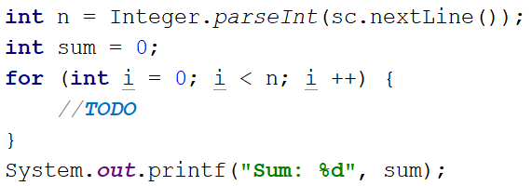

Multiplication Table
You will receive an integer as input from the console. Print the 10 times table for this integer. See the examples below for more information.

Output
Print every row of the table in the following format:
{theInteger} X {times} = {product}

Constraints
- The integer will be in the interval [1…100]

Examples
Input | Output |  | Input | Output
5 | 5 X 1 = 5  5 X 2 = 10  5 X 3 = 15  5 X 4 = 20  5 X 5 = 25  5 X 6 = 30  5 X 7 = 35  5 X 8 = 40  5 X 9 = 45  5 X 10 = 50 |  | 2 | 2 X 1 = 2  2 X 2 = 4  2 X 3 = 6  2 X 4 = 8  2 X 5 = 10  2 X 6 = 12  2 X 7 = 14  2 X 8 = 16  2 X 9 = 18  2 X 10 = 20

Multiplication Table 2.0
Rewrite your program so it can receive the multiplier from the console. Print the table from the given multiplier to 10. If the given multiplier is more than 10 - print only one row with the integer, the given multiplier, and the product. See the examples below for more information.

Output
Print every row of the table in the following format:
{theInteger} X {times} = {product}

Constraints
- The integer will be in the interval [1…100]

Examples
Input | Output |  | Input | Output |  | Input | Output
5  1 | 5 X 1 = 5  5 X 2 = 10  5 X 3 = 15  5 X 4 = 20  5 X 5 = 25  5 X 6 = 30  5 X 7 = 35  5 X 8 = 40  5 X 9 = 45  5 X 10 = 50 |  | 2  5 | 2 X 5 = 10  2 X 6 = 12  2 X 7 = 14  2 X 8 = 16  2 X 9 = 18  2 X 10 = 20 |  | 2  14 | 2 X 14 = 28

Even Number
Take as an input an even number and print its absolute value with a message: "The number is: {absoluteValue}". If the number is odd, print "Please write an even number." and continue reading numbers.

Examples
Input | Output |  | Input | Output
1  3  6 | Please write an even number.  Please write an even number.  The number is: 6 |  | -6 | The number is: 6

Refactor Sum of Odd Numbers
You are assigned to find and fix the bugs in an existing piece of code, using the debugger. You should trace the program execution to find the lines of code that produce incorrect or unexpected results.
You are given a program (existing source code) that prints the next n odd numbers (starting from 1) and on the last row, prints the sum of them.

Examples
Input | Output |  | Input | Output
5 | 1  3  5  7  9  Sum: 25 |  | 3 | 1  3  5  Sum: 9

SumOddNumbers.java
Scanner sc = new Scanner(System.in);
int n = Integer.parseInt(sc.nextLine());
int sum = 1;
for (int i = 0; i <= n; i++) {
System.out.print(2 * i + 1);
sum += 2 * i;
}
System.out.printf("Sum: %d%n", sum);

